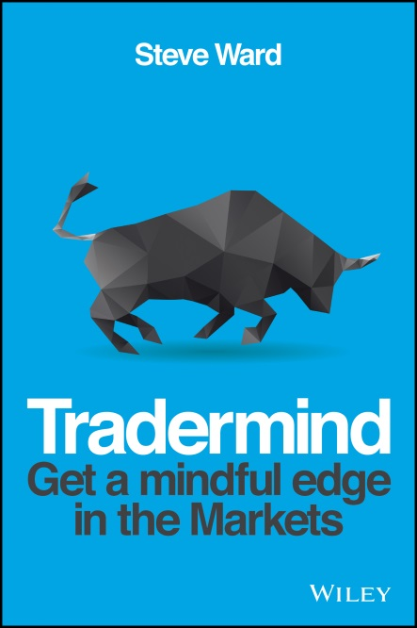
TraderMind
Get a Mindful Edge in the Markets
Steve Ward

A unique and practical guide which harnesses the power of mindfulness techniques to enable traders to break out of their old habits and take their trading performance to new levels

- INCLUDES AN 8 WEEK TRAINING PROGRAM AND VIDEOS - coaching the user in key mindfulness techniques to help reinforce the messages and strategies contained in the book.

- COMPELLING AUTHOR PLATFORM – Steve Ward works with a number of trading platforms - Trade With Precision (Global), Which
Way Today (UK/Europe), Trading Tutor (USA), LBR Group (USA), Lex van Dam Academy (UK/Europe), Market Technicians Association (Global). He writes for Traders Magazine, FX Trader Magazine and Shares Magazine and is well connected at LIFFE/NYSE, CME, London Stock Exchange, CMC Markets (Australia), ETX Capital, InterTrader and TDWaterhouse. He also has a personal network of over 1300 traders, and 2000 names on his own High Performance Global Ltd database.

TraderMind is an essential resource for understanding and applying mindfulness based approaches that help to enhance an individual trader’s overall performance. Based upon extensive research and practical application in the real world of the trading floor, TraderMind includes methods, tactics and techniques to build and enhance awareness and insight, which help manage thoughts and emotions and maximize trading performance. The author demonstrates how to overcome habitual or impulsive trading behaviours, manage energy levels, become more attuned to and responsive to the market, more situationally aware and build patterns of effective trading behaviour. By developing these skills and good behaviours traders can overcome inherent biases and, ultimately, improve their trading decisions.

The techniques outlined in TraderMind can be utilized as core competencies of trading psychology or can be used to complement other behavioural methods and strategies. The TraderMind tool-set does not replace the need for basic trading skills, knowledge, strategy, or key performance enablers such as preparation and performance analysis. Rather, TraderMind is designed to act as a facilitator or multiplier to enhance trader decision-making and improve overall performance.

Using the techniques outlined in this book will help any investor to better compete with the best traders and investors in the world who employ a combination of technical skills and market knowledge, strategy, self awareness and mindful insight.

9781118318546 • Paperback • October 2014 • 240 pages • £18.99 / $32.50 / €22.80

About the Author
Steve Ward works with financial traders, trading teams and leaders in proprietary trading groups, energy companies, banks and funds across the world utilising his expertise in the areas of performance, psychology, lifestyle management and making decisions under conditions of high stress, risk and uncertainty. He is the author of High Performance Trading and Sportsbetting To Win, and was the consultant trading performance coach to BBC television’s Million Dollar Traders series.

